Use of Thin dressings Under N95 respirators: Exploring the Impact on Mask Seal and Skin Preservation during the Covid-19 Pandemic

Authors: Guschel, Susan MS, ANP-C, CWON Chmiel, Karen, MS, ANP-C, CWON; Rosenstein, Jennifer, DC, MS, NP-C, ACNS, CWON
Abstract:

During the height of the Covid-19 pandemic, medical staff at Stony Brook University Hospital, a level 1 Trauma Center in the northeast US, experienced facial irritation and skin breakdown under their N95 respirators due to the need for prolonged usage. Purpose: The Certified Wound, Ostomy Nurse Practitioner staff were charged with developing recommendations for prevention and treatment that also would not compromise the seal of the respirators. Method: With the assistance of a Health Care Safety Specialist from the Environment Health and Safety department, certain thin dressings were tested using an ambient particle counting device that was used to conduct Fit Testing by providing quantitative assessments of face-seal leakage. Results: The fit testing results showed that use of thin dressings applied to the face under the N95 respirators did not affect the seal of the respirator. Conclusion: Thin dressings as tested were permitted for use by staff under their N95 respirators and were an effective prevention and treatment method for facial skin issues.

Key Words: Covid-19 Pandemic, N95 Respirator, Facial skin breakdown, Prevention, Treatment

Introduction:
During the early stages of the Covid-19 pandemic 2020, front line hospital staff at Stony Brook University Hospital (SBUH), a 624 bed teaching hospital and Level 1 trauma center in the Northeast, US, began to experience facial skin breakdown under their N95 respirators due to the extended wear time required while caring for COVID-19 patients. At the height of the COVID pandemic, the census of SBUH rose to over 1,200 patients which increased the duration of the time that the staff were wearing Facial Protective Equipment (FPE). The SBUH’s Certified Wound and Ostomy Nurse (CWON) Nurse Practitioners (NPs), were contacted by the Chief Nursing Officer to develop mask- related skin irritation prevention and treatment recommendations for the health care staff. The recommendations had to encompass products on the hospital formulary and be completed within a 48 hour deadline.
Professional organizations for pressure injury management, wound and ostomy care, published guidelines for protecting skin under N95 masks/ Facial Protective Equipment (FPE) (WOCN, 2020; NPIAP, 2020; AAWC, 2020) and these were reviewed. These agencies offered the recommendation to apply a liquid skin sealant prior to donning FPE as both a preventative measure and/or treatment for skin breakdown. Application of thin, prophylactic dressings to be placed under FPE was acknowledged as a possible mitigation for skin injury, but this implementation was proposed with caution, considering the lack of evidence- based information to ensure uncompromised mask fit and seal.
Method:
The CWON NPs reached out to the Environmental Health and Safety (EHS) department for assistance in determining an acceptable method of performing fit testing of the N95 respirators with dressing use. With the assistance of a Health Care Safety Specialist from the (EHS) department, fit testing was performed using the 3M ™ N95 Health Care Particulate Respirators product numbers 1860 and 1860S on two separate individuals with different facial structures. Testing was done using a 3M™ Cavilon ™ (liquid skin barrier) as the control product, a 3M™ Tegaderm ™ (transparent film dressing), Molnlycke ® Mepilex Lite (a light silicone based adhesive foam dressing) and Convatec DuoDerm® Extra Thin (an extra thin hydrocolloid dressing).
The fit testing process entailed the use of the PortaCount ® Pro+ respirator fit testing unit, which is an ambient particle counting device that provides quantitative assessments of face-seal leakage, (see figure 1) which is Occupational Safety and Health Administration (OSHA), Canadian Standards Association (CSA), Health, Safety and Environment (HSE) and American National Standards Institute (ANSI) compliant for all tight-fitting respirators. The N95 respirator was fitted with a probe that is connected to the PortaCcount® Pro+ unit via a tube assembly. The probe is installed using a sharp piercing tool that pierces the N95 respirator and “loads” the probe to the mask within the “breathing zone” of the respirator, which is in the center of the respirator between the person’s nose and mouth (see Figure 2).
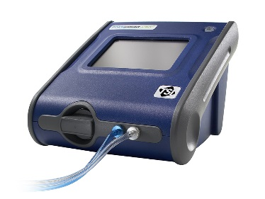Figure 1- Portacount® Pro+ Fit Testing Unit

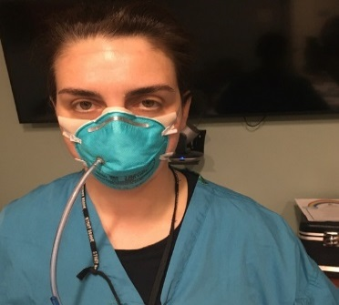 Figure 2- N95 Respirator loaded with probe and tube assembly

The PortaCount® Pro + fit tests the mask wearer while performing normal breathing, deep breathing, head rotation side to side, moving the head up and down (flexion/extension of neck), talking, grimacing, bending over at the waist, and lastly, a repeat of normal breathing. The PortaCount Pro+ calculates a “Fit Factor” grade for each of these exercises and an overall “Fit Factor” grade for all the exercises combined.
The Fit Factor is the ratio of the amount of particles measured inside and outside of the respirator. It is the numerical result of the quantitative fit test performed on a respirator’s face piece, which indicates the effectiveness of the seal against the face. It is expressed as a ratio that identifies how many times cleaner the air inside the respirator’s face piece is in comparison to the air outside of the face piece. The accepted fit factor for a half face mask is 100. This ratio indicates that the air inside the face piece is 100 times cleaner than the air outside of the face piece.
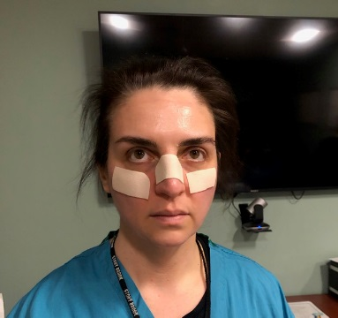 Figure 3- Application of thin dressings to the nose bridge and cheek bones.
Figure 4- N95 respirator placement over thin dressings

As the locations on the face that most frequently experienced skin issues were the bridge of the nose and the cheek bones, the dressings used for testing were placed on the face in those areas. (See figure 3). The dressings were cut into a rectangular shape as follows: a 2.5 cm x 6 cm piece was placed on the bridge of the nose, while a 2.5cm x 2.5cm piece was placed on each cheekbone. The dressings were placed to sit under the edges of the N95 respirator and were consistent with both test subjects with no dressing overlap.
Limitations:
Two subjects with different facial structures were evaluated. The sample size was limited not only because the recommendations were needed emergently, but because the fit testing procedure itself destroys the mask during the process and N95 respirator supplies were tightly controlled at the height of the pandemic.
Results:
PortaCount® Pro+ N95 Respirator Fit Test findings:
Product | Control: Liquid Skin Barrier | Light Silicone Based Adhesive dressing | Extra Thin Hydrocolloid Dressing | Transparent Film Dressing
Participant #1 | 200 | 148 | 167 | 186
Participant #2 | 198 | 119 | 118 | 153

A fit factor of 100 or greater reflects an effective seal with a grade of 200+ reflecting maximum seal detection. Based upon the testing of the liquid skin barrier and thin film dressings, both participants had an adequate, protective seal with the N95 respirator.
Discussion:
With the Fit Testing results, the Light Silicone Based Adhesive Dressing and the Extra Thin Hydrocolloid Dressing were able to be successfully incorporated into the hospital mask -related skin breakdown prevention practice over the past 3 months. While liquid skin barrier and transparent film dressings were available for use as well, they were not chosen frequently by the staff for skin protection as they did not reduce injury caused by pressure or reduce the discomfort from existing skin breakdown. They were often used as a skin protectant barrier under the thin dressings.
In reviewing hospital based statistics during the last 3 months while thin dressings were used under the N95 respirators, the percentage of hospital staff testing positive for Covid-19 was not any higher than the overall community rate. It was determined by the results from the fit testing, that using the thin dressings under the N95 respirators, would most likely not affect the fit and seal while helping to prevent and treat skin breakdown of the nose and cheek bones.
Conclusion:
The nature of this evaluation was to determine if the use of certain wound care products used under N95 respirators, would assist front line hospital staff in the prevention and treatment of skin breakdown without interfering with N95 respirator seal. Fit testing procedures were able to show an adequate seal with thin dressings. Feedback received from the hospital staff was that the dressings were both effective in prevention and treating skin breakdown of the nose bridge and cheek bones. This paper is for informational purposes only and health care facilities are urged to use their own clinical judgement in making recommendations to their staff.
The evaluation, which should not be considered a research study, was completed under the duress of a pandemic situation with recommendations that were needed emergently.
Because there is a range of variables involved, considerations for future evaluations or research should include an IRB approved randomized clinical study with a larger sample size that incorporates a diverse group of facial shapes and N95 respirator types.
Stony Brook University Hospital purchased a generator to autoclave the N95 respirators for reuse in the future. The N95 masks could not be in contact with makeup, facial creams, and ointments in order to be successfully cleaned, so the SBUH “Save a Mask” campaign was initiated. The staff were shown videos of colleagues who directed them to go makeup and facial care product-free while wearing a N95 respirator. The elimination of cream and ointment based skin care products added to the challenge of providing skin care recommendations with the respirator use. Another question to consider, if respirators are to be autoclaved for reprocessing, will the use of liquid skin sealants and dressings affect the integrity of the masks and interfere with the autoclave process?

Affiliations:
Susan Guschel is a Certified Adult Nurse Practitioner and Certified Wound and Ostomy Nurse at Stony Brook University Hospital, Stony Brook, NY. Karen Chmiel is a Certified Adult Nurse Practitioner and Certified Wound and Ostomy Nurse at Stony Brook University Hospital, Stony Brook, NY. Jennifer Rosenstein is a Certified Adult Nurse Practitioner and Certified Wound and Ostomy Nurse at Stony Brook University Hospital, Stony Brook, NY.
Acknowledgements: Ellen O’Hare, Health Care Safety Specialist, Stony Brook University Hospital, Stony Brook, New York.

Reference List

1. Guidance for Maintaining Skin Health When Utilizing Protective Masks for Prolonged Time Intervals. WOCN.org. https://cdn.ymaws.com/www.wocn.org/resource/resmgr/doc/Guidance _for_Skin_Health_Upd.pdf. Published April, 2020. Accessed on April 20, 2020.

2. NPIAP Position Statements on Prevention Injury with N95 Masks. NPIAP.com. https://cdn.ymaws.com/npiap.com/resource/resmgr/position_statements/Mask_Position_Paper_FINAL_fo.pdf. Published 2020. Accessed on April 20, 2020.

3. Protocol for Prevention of Facial/Ear Breakdown from Respiratory Devices. https://aawconline.memberclicks.net/. https://aawconline.memberclicks.net/assets/docs/COVID-19/Infection_Control/Protocol_for_Prevention_of_Facial_Breakdown_N95_w_disclaimer.pdf
Published April, 8, 2020. Accessed on April 20, 2020.

